Long Lane C.E. Primary School

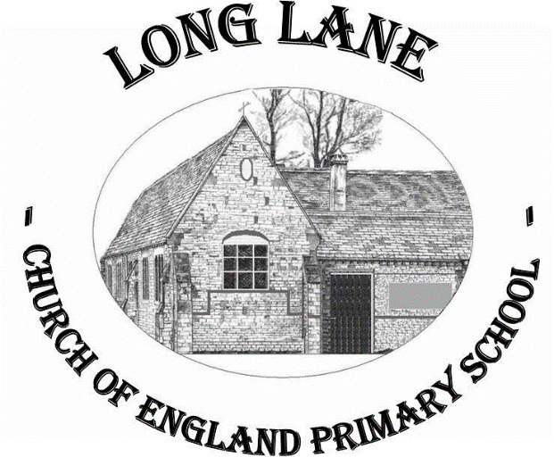

Admissions Policy

Policy written – September 2021

Reviewed – September 2022

To be reviewed – September 2023
Admissions Policy

Admissions Policy Statement
Children are legally entitled to a place in school at the beginning of the term after their fifth birthday. The Governing Body of Long Lane Church of England Primary School has considered Derbyshire County Council’s admission criteria and has adopted the policy whereby children will be admitted full time as follows:

- A child whose fifth birthday falls on or between 1st September and 31st August may start school in September.

Parents can however, request that the date their child is admitted to the school is deferred until later in the school year or until the child reaches compulsory school age in that school year.

Derbyshire Admissions Procedure
Individual pupils who have a statement of special educational needs which names the school will be admitted. In deciding on admissions to all community and voluntary controlled schools in Derbyshire, the following order of priority will be adopted.

- Looked After Children and all previously looked after children including those who appear (to the admissions authority) to have been in state care outside England and ceased to be in state care as a result of being adopted.
- Children living in the normal area (see note one) served by the school at the time of application and admission who have brothers or sisters (see note two) attending the school at the time of application and admission.
- Children living in the normal area (see note one) served by the school at the time of application and admission.
- Children not living in the normal area (see note one) served by the school but who have brothers or sisters (see note two) attending the school at the time of application and admission.
- In the case of voluntary controlled church schools, children whose parents request a place on religious grounds (see note three).
- Other children whose parents have requested a place.

Where, in the case of 2,3, 4, 5 or 6 above, choices have to be made between children satisfying the same criteria, those children living nearest to the school (measured by the nearest available - see note four) will be given preference.

Procedures: Application for places
Admissions are dealt with by the Local Authority. Parents have to complete a common application form (PAF1) in order to apply for places at all Derbyshire schools. The form enables parents to express their preferences, by naming the schools they are applying to; giving reasons for their application and listing their choice of schools in priority order. Completed forms need to be returned to the Admissions Department at Derbyshire County Council.
Places will then be allocated according to Derbyshire’s published admissions criteria.
Decisions will be made as soon as possible after March.

Appeal Mechanism
Where parents are unsuccessful in securing a place at their preferred school, the arrangements for an appeal can be obtained from the Primary Admissions and Appeals Team, Derbyshire County Council.

Policy Review
This policy will be reviewed in the light of any new LA directives on admissions policy.

