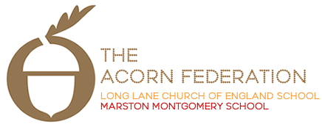

Meadow Class

Curriculum Overview

Summer Term 2023

English
Gangster School – Kate Wiseman
Narrative; Advert / Persuasive Speech
The Highwayman - Alfred Noyes
Factsheet/Poetry
Mathematics
Number, Addition and Subtraction, Fractions, Measurement, Geometry, Multiplication, Shape, Statistics
Science
Yr 3/4:
Sum 1
Living Things and Their Habitats
Sum 2
Animals, Including Humans
Yr 5/6:
Sum 1
Living Things and Their Habitats
Research famous naturalist – Jane Goodall
Sum 2
Living Things and their Habitats (Grouping, Classification)
Religious Education
Sum 1: For Christians, when Jesus left, what was the impact of Pentecost?
Sum 2: Is it better to express your belief in arts and architecture or in charity and generosity?
Art and Design
Working in 3-Dimensions
Telling Stories Through Making
Computing
Creating Media - Audio production
Programming B – Repetition in games
Design and Technology
Y3/4 - Mechanisms & Pneumatics: Greek Theatre
Y5/6 - Cooking and Nutrition: Celebrating Culture and Seasonality: Tomato Soup
Geography
South America
History
Crime and Punishment from Anglo-Saxons to present
Languages (Yr 5/6)
Qu’est-ce que c’est?
Je m’habille
(Yr 3/4 will reinforce times tables)
Music
Bringing us together
Glockenspiel
Personal, Social and Health Education
Being Me
Relationships
RSE
Yr 5/6 – separate content to be provided in Summer 2.
Physical Education
Swimming
Athletics

Dates for this term

