Presentation Policy

Policy written – June 2020
Reviewed – January 2023
To be reviewed – January 2024

Presentation Policy

Purpose
The purpose of this policy is to ensure a consistently high standard of presentation across the federation which all children and staff recognise, understand and follow. This policy is to be used in line with the individual guidance for each year group / class which outlines the expectations and progression throughout school.

Application
These expectations are intended to apply to the vast majority of children in our school. Occasionally a decision will need to be made to personalise the presentation expectations for a child who has such specific needs that these expectations could be a barrier to their progress (e.g. a child with physical difficulties writing).

Making it a reality
Staff will ensure that presentation of work is actively taught as it will not ‘just happen’. It should be a main focus at the start of each academic year and then be referred to periodically throughout the year. It is the responsibility of all staff to ensure children adhere to the presentation policy, not the responsibility of the children.

Where possible, all staff should ensure that presentation is celebrated through:
- Displaying work with a high standard of presentation.
- Celebrating work with a high standard of presentation in whole class situations.
- Ensure good presentation is rewarded in line with whole school behaviour policy (praise / Dojos).
- Sharing of good work in celebration assembly.
- Handwriting will be taught in line with the handwriting policy on a regular (at least weekly) basis. The focus of these lessons will be correct letter formation and cursive handwriting. Children will need to be taught how to write in a cursive style.

General rules
- All drawings and diagrams should be in pencil.
- Felt pens and gel pens are not used in exercise books.
- Coloured pens will only be used for specific reasons by children, e.g. blue pen for marking, self-evaluation and responding to marking.
- Pencil crayons should be used in exercise books.
- One single line is used to cross out mistakes.
- No writing or doodling on covers, the inside covers of books or in books.
- No doodling on pages in books or on covers.

Starting new work
Children should be taught where to begin a new piece of work. As a general rule, children will start a new page when there are only a few lines left, otherwise they rule off and use the same page.

Monitoring
Presentation will be monitored by the Senior Leadership Team on a regular basis through:
- Work Scrutiny
- Standard’s Reviews
- Lesson Observations
- Pupil interviews

Garden Class Expectations
 | Reception | Year 1 | Year 2
Date and LO | The LO sheet with date and success criteria is stuck into books.  The short date is used, e.g. 09/01/23 in Maths books and foundation subjects.  The long date is used, e.g. Monday 9th January 2023 in English books
Equipment | - - Children will always write in pencil in books.  - - Pencil Crayons will be used in exercise books. | - All work will be written in pencil. Children will be taught how to sharpen pencils and reminded to ensure pencils are sharp.  - only Pencil Crayons will be used in exercise books.  - Children will be expected and taught how to use a ruler to draw lines, including underlining, diagrams and labelling.
Responding to Marking / editing |  | Blue pen will be used | - Blue pen will be used
Staff Encourage / expect | - correct letter formation and left to right orientation  - to try and write in a straight line | - correct letter formation of both upper and lower case letters. Following the scheme  - Left to right orientation  - children to write in a straight line and on the line.
Handwriting | Staff will emphasise correct letter formation through the regular teaching of handwriting  - Correct formation is reinforced all the time.
Self-correction of errors |  | - Rubbers will be used to correct errors. | Rubbers will be used to correct errors
Maths Books |  | - Only pencil to be used  - Children to be taught to use 1 digit per square
Care of Books | - Children will not doodle on pages or on the covers of their books
Pieces of Paper | Will be stuck neatly into books.  No loose papers once used.

Meadow Class
 | Year 3 and 4 | Year 5 and 6
Date and LO | The LO sheet with date and success criteria is stuck into books.  The short date is used, e.g. 09/01/23 in Maths books and foundation subjects.  - The long date is used, e.g. Monday 9th January 2023 in English books
Equipment | - - Children will write in pencil.  - - Only Pencil Crayons will be used in exercise books.  - - All maths work will be completed in pencil except for ‘blue Pen’ responding to marking.  - - Children will be expected and taught how to use a ruler to draw lines, including underlining, diagrams and labelling.  - - Children will use guidelines if writing on plain paper. | - Children need to earn the right to use pen in their work. Only when teachers are sure that children can write consistently well in pen, will a pupil use pen.  - Children will write in black pen.  - Pens will be used for selected pieces of work. This will improve the presentation of the editing process  - Only Pencil Crayons will be used in exercise books.  - All maths work will be completed in pencil except for ‘blue Pen’ RTM.  - Children will be expected to use and taught how to use a ruler to draw lines, including underlining, diagrams, labelling and crossing out  - Children will use guidelines if writing on plain paper.
Responding to Marking / editing | Blue pen will be used neatly
Staff Expect | - correct letter formation of both upper and lower case letters.  - cursive handwriting  - Left to right orientation  - children to write in a straight line and on the line.
Handwriting | Staff will emphasise correct letter formation through the regular teaching of handwriting  Correct formation is reinforced all the time.
Self-correction of errors | - Rubbers will be used to correct errors, sparingly | When writing in pen children will indicate an error with one neat line.  Rubbers will be used to correct errors when using pencil, sparingly
Maths Books | - Only pencil to be used  - Children to use 1 digit per square
Care of Books | - Children will not doodle on pages or on the covers of their books.
Pieces of Paper | Will be stuck neatly into books.  No loose papers once used.

Foundation Subjects: Knowledge Organisers and LO overview

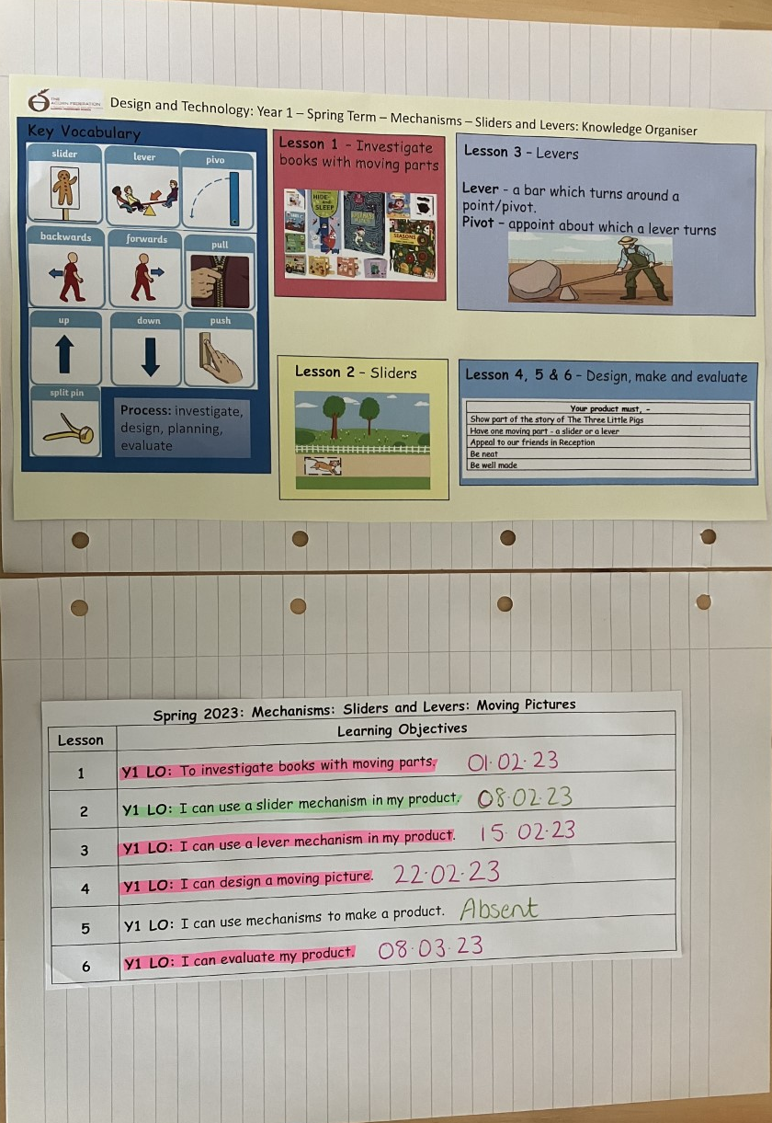
The LO overview has a title which includes the term the unit is being taught..
Only the LOs for that year group are on the LO overview. sheet.
The whole LO is highlighted to indicate level of success. ‘Perfect Pink’ or ‘Green for Growth’.
The date is written at the end of the highlighted LO.
If a pupil is absent please write ‘Absent’ at the end of the LO and do not highlight it.
If a pupil does interventions please write ‘Interventions’ at the end of the LO.

All Subjects

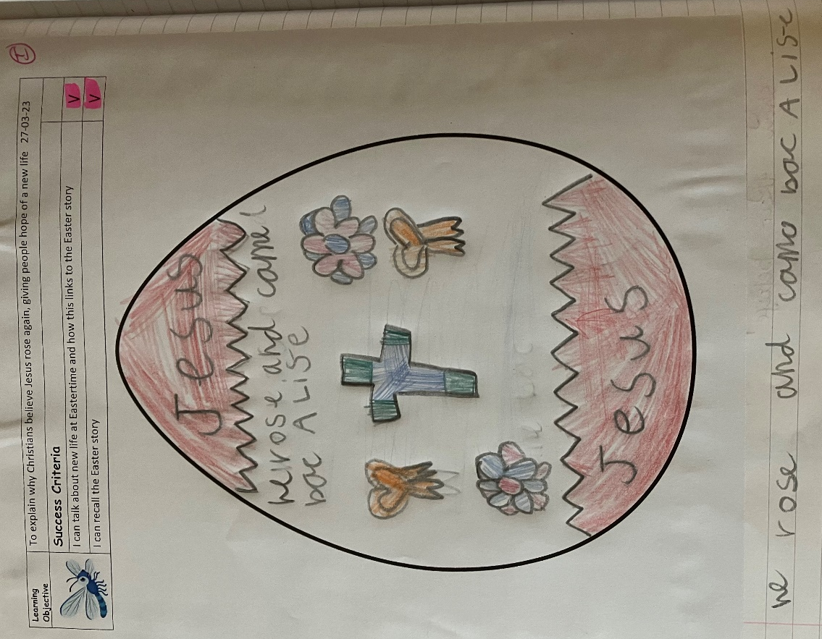 | Supply teachers mark in orange. They still need to use pink or green to highlight the success criteria though. This way we know if the children have achieved the success criteria or not.  Each piece of work is dated. This is on the top line of the LO sheet.  Success criteria are highlighted to show achievement.  - Perfect pink  - Green for Growth  I, S or G are used to indicate level of support.  I, S or G are used to indicate level of support.
Children respond to marking in blue.
Supply teachers mark in orange.

