Garden Class – Spring 3
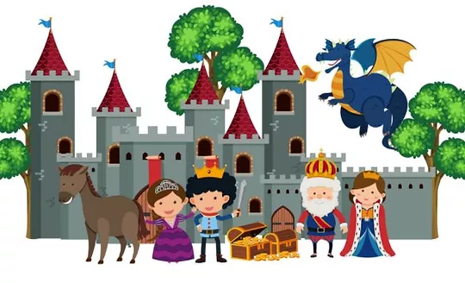
Turrets and Tiaras - Homework Tasks

Design and Technology:  Build a castle out of Lego or cardboard. This can be small so you can bring it in to show the class.  Can you design a costume fit for a knight or princess? | English:  Can you write a story involving a prince, princesses and dragons? What adjectives will you use to describe your dragon?  Create an acrostic poem for either turrets or tiaras. If you want a challenge make one for both. | Art:  Use a range of media (paint, collage, crayons or felt tips) to create a picture of a castle, a woodland scene or the people that would live in the castle.
Geography:  Research and find on a map locations of famous castles. Which is your favourite one and where is it found? | Maths:  There are 12 dragons and 1 flies away, how many are left?  If there are 15 dragons and 5 more come to visit how many dragons are there now?  Create a crown with a repeating pattern of 2D shapes. | History:  Research famous castles in the UK. What interesting facts can you find out about them? Who used to live there? How many rooms do they have?  Challenge – can you find any castles/palaces linked to Henry V111?

